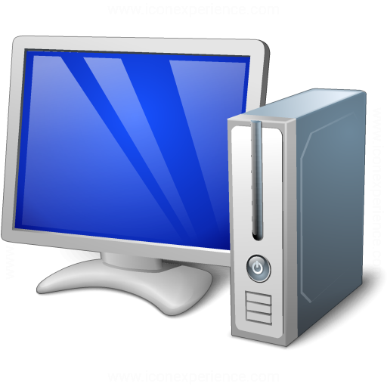

1 Nodejs, Socket IO, Socket Client, Express

2 Oracle Database

Request to server

PL SQL   
call Restful, http via

Trigger on insert, update

Send to Socket Client

For Monitor data

Send Socket Client

Send Socket Client

Broadcast to “ip” emit('message',{});

IP map session client

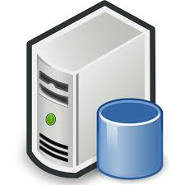

Desktop Client

Web Client

Web Client